Simulation Phase

I implemented the simulation code in Python programming language with a strong emphasis on SimPy 2.3.1, which I learned and practice while doing the simulation for the first homework. In this simulation, the modelling is focused mostly on the active components, namely the behaviour of hosts. Thus, the Process based programming approach of SimPy is a very suitable for this task.

I implemented a script, which can be found on the next page, that simulates the given situation for the varying number of CW_{min} and varying number of hosts with limitless and full queues. The duartion is tracked by the constant of 100,000 serviced packets in total. The simulation is split into two main functions. Source.generate() refills the waiting queues of hosts for left packets and it is responsible for picking random back-off values and checking for collisions. If a collision occurs, it is handled in this function, if not it is passed to the WLAN link to get service. The WLAN link is modeled by Packet.service() function. It simply advances time and keeps track of the packets that got served in the past.

The measured result is the overall throughput of the system, which is calculated as the ratio of total number of served bits to the time duration. It is then converted to a pecentage scale, since individual rates of hosts are fixed to 5.5Mbps and that it can be treated as the overall rate of the whole system. At the end of each run, results are appended to a text file, from where they are retrieved and analyzed later on.

CW_{min} / N | 2 | 4 | 8 | 16 | 32 | 64 | 128 | 256 | 512
5 | 91.8651 | 91.7884 | 91.8149 | 91.7897 | 91.9291 | 91.7071 | 91.8053 | 91.7060 | 91.4944
10 | 89.9101 | 89.9324 | 89.8691 | 90.0904 | 90.1238 | 89.7993 | 89.9053 | 89.8143 | 89.8564
15 | 88.4931 | 88.5164 | 88.3671 | 88.5873 | 87.9696 | 88.2787 | 88.3769 | 88.4612 | 88.2328
20 | 86.9755 | 86.9089 | 87.0268 | 86.9026 | 86.7952 | 87.0989 | 87.2080 | 87.1103 | 87.1798
25 | 85.7533 | 85.6739 | 85.8360 | 85.8769 | 85.6309 | 85.8497 | 85.8809 | 85.7918 | 85.7284
30 | 84.4863 | 84.6557 | 84.6838 | 84.5612 | 84.4682 | 84.5521 | 84.7127 | 84.7489 | 84.3639
35 | 83.6596 | 83.6302 | 83.4771 | 83.4824 | 83.5700 | 83.4789 | 83.4196 | 83.4747 | 83.6517
40 | 82.7827 | 82.6858 | 82.5146 | 82.5240 | 82.7440 | 82.7396 | 82.7193 | 82.5873 | 82.7746
45 | 81.5833 | 81.9025 | 81.7774 | 81.7053 | 81.7495 | 81.7881 | 81.9032 | 81.7426 | 81.5976
50 | 80.9728 | 80.8501 | 81.0768 | 81.0497 | 80.8370 | 80.8064 | 80.8567 | 81.1299 | 80.8844
Figure I: The overall throughput percentages for differing CW_{min} and number of hosts

Analysis

By making use of a Python graphing library, Matplotlib, I plotted the Figure I, for throughput as a function of N, for all fixed numbers of hosts.
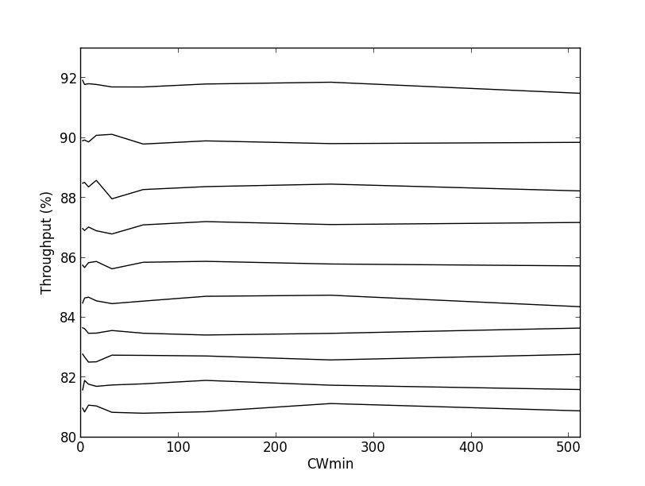

Graph I:Throughput vs. CW_{min}, for each distinct line representing a fixed number of hosts; ascending order in downwards direction.

As expected, there is a clear and strong negative correlation between N and throughput. The choice of CW_{min} seems to have a much smaller, fluctuating effect on the performance rate, rather than changing it significantly. However, since the demand of a link is not determined by the network manager, having control over CW_{min} provides optimization up to a degree.

In this optimization problem, we consider a WLAN link with a given host demand and our task is to find the best possible CW_{min} value. Thus, the number of hosts can be considered as constant for a given link, CW_{min} as the independent variable and throughput as the dependent variable to be maximized. In this manner, I reviewed the results I got from the simulations plotted the best CW_{min} choices for each N, along with a best-fit line to visualize the correlation between link.
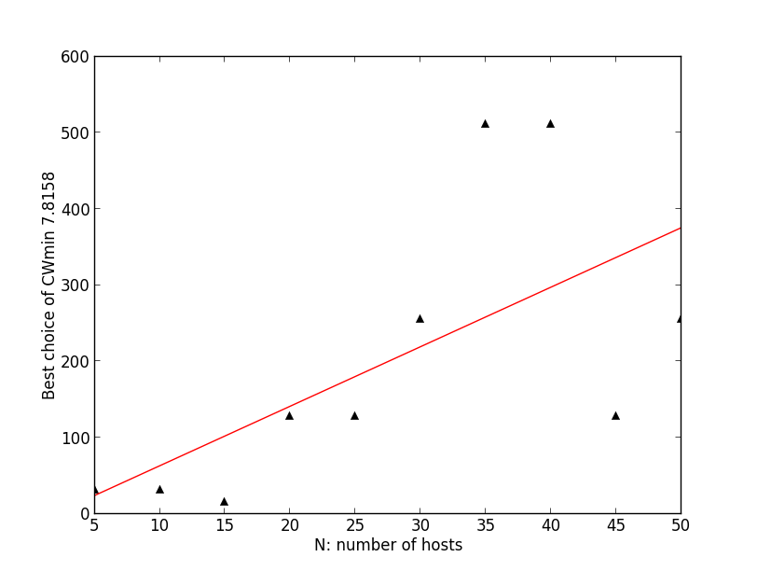
Graph II: The scatter plot of best CW_{min} vs. N along with the best-fit line with slope = 7.8158
As I expected, N and optimum CW_{min} are positively related. Intuitively, as the number of hosts increase, the probability of collisions also increase, which is compensated by an increase in the minimum contention window. The choice of larger contention window highly increases overhead exponentially and decreases the collision probability in the same order. Thus, by choosing contention window, we actually choose the balance between collision probability and overhead, which actually are the only
sources of delay for our case.

For Part b, a plot of throughputs for best choice of CW_{min} and for CW_{min} = 32 as a function of N is provided in Graph III.
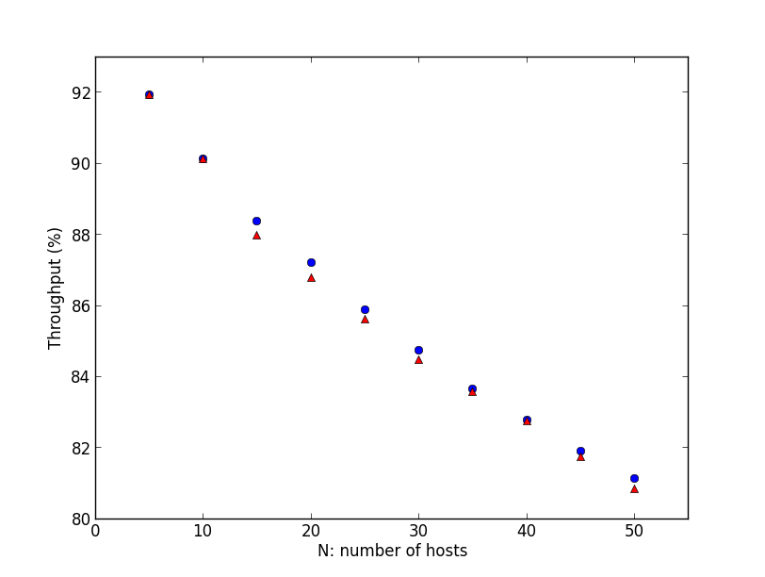
Graph III: Throughput percentage as a function of N for (red: CW_{min} = 32 and blue: best CW_{min})

As I stated earlier, the choice of minimum contention window doesn’t drastically change the throughput, but causes minor shifts. The level of these shifts are clearly demonstrated on Graph III. Although as a choice from the middle of options 32 is a relatively good choice, the choice of any CW_{min} regardless of number of hosts would affect the delay on a very small scale.

In this sense, having a control over CW_{min} chocie does provide a minor optimization opportunity for us, but it’s affect is quite small. So, if such small maximizations are not required, which is the case for most of the time, CW_{min} can simply be fixed to an intermediate value among possible choices. The advantage of an intermediate value over any lower or upper boundary values of a CW_{min} option set, is it’s flexibility. An intermediate value is balanced in terms of the mentioned overhead vs. collision probability trade-off. Hence, it is highly likely to be either the best or a close to best choice for most of the cases.

Comments on the Simulation Phase
- When I have completed the implementation, I made a few trials with different parameters and packet counts. I observed that, the differences between the case for 100,000 packets and 1,000,000 packets are not very significant. After consulting one of my classmates about this issue and having a similar feedback, I decided to go with the smaller packet count to save some time. This choice might have caused minor imprecisions.
- In the question, the packet sizes are specified, but we are not given any information about the ACK packets. Since the aim of this honeworks is comparison, I chose a fixed value of 100 bytes, considering the fact that, ACKs are generally much shorter packets than the data packets. This was an arbitrary choice and I don’t think it would effect the results.
- The trial CW_{min} values are very sparsely distributed, so a small change in the random process can cause a huge shift in the actualization of the results. To obtain a more precise result, we might have considered more sampels with smaller intersample spaces.

